**SaveFood System**

Entity – Relationship (ER) Diagram

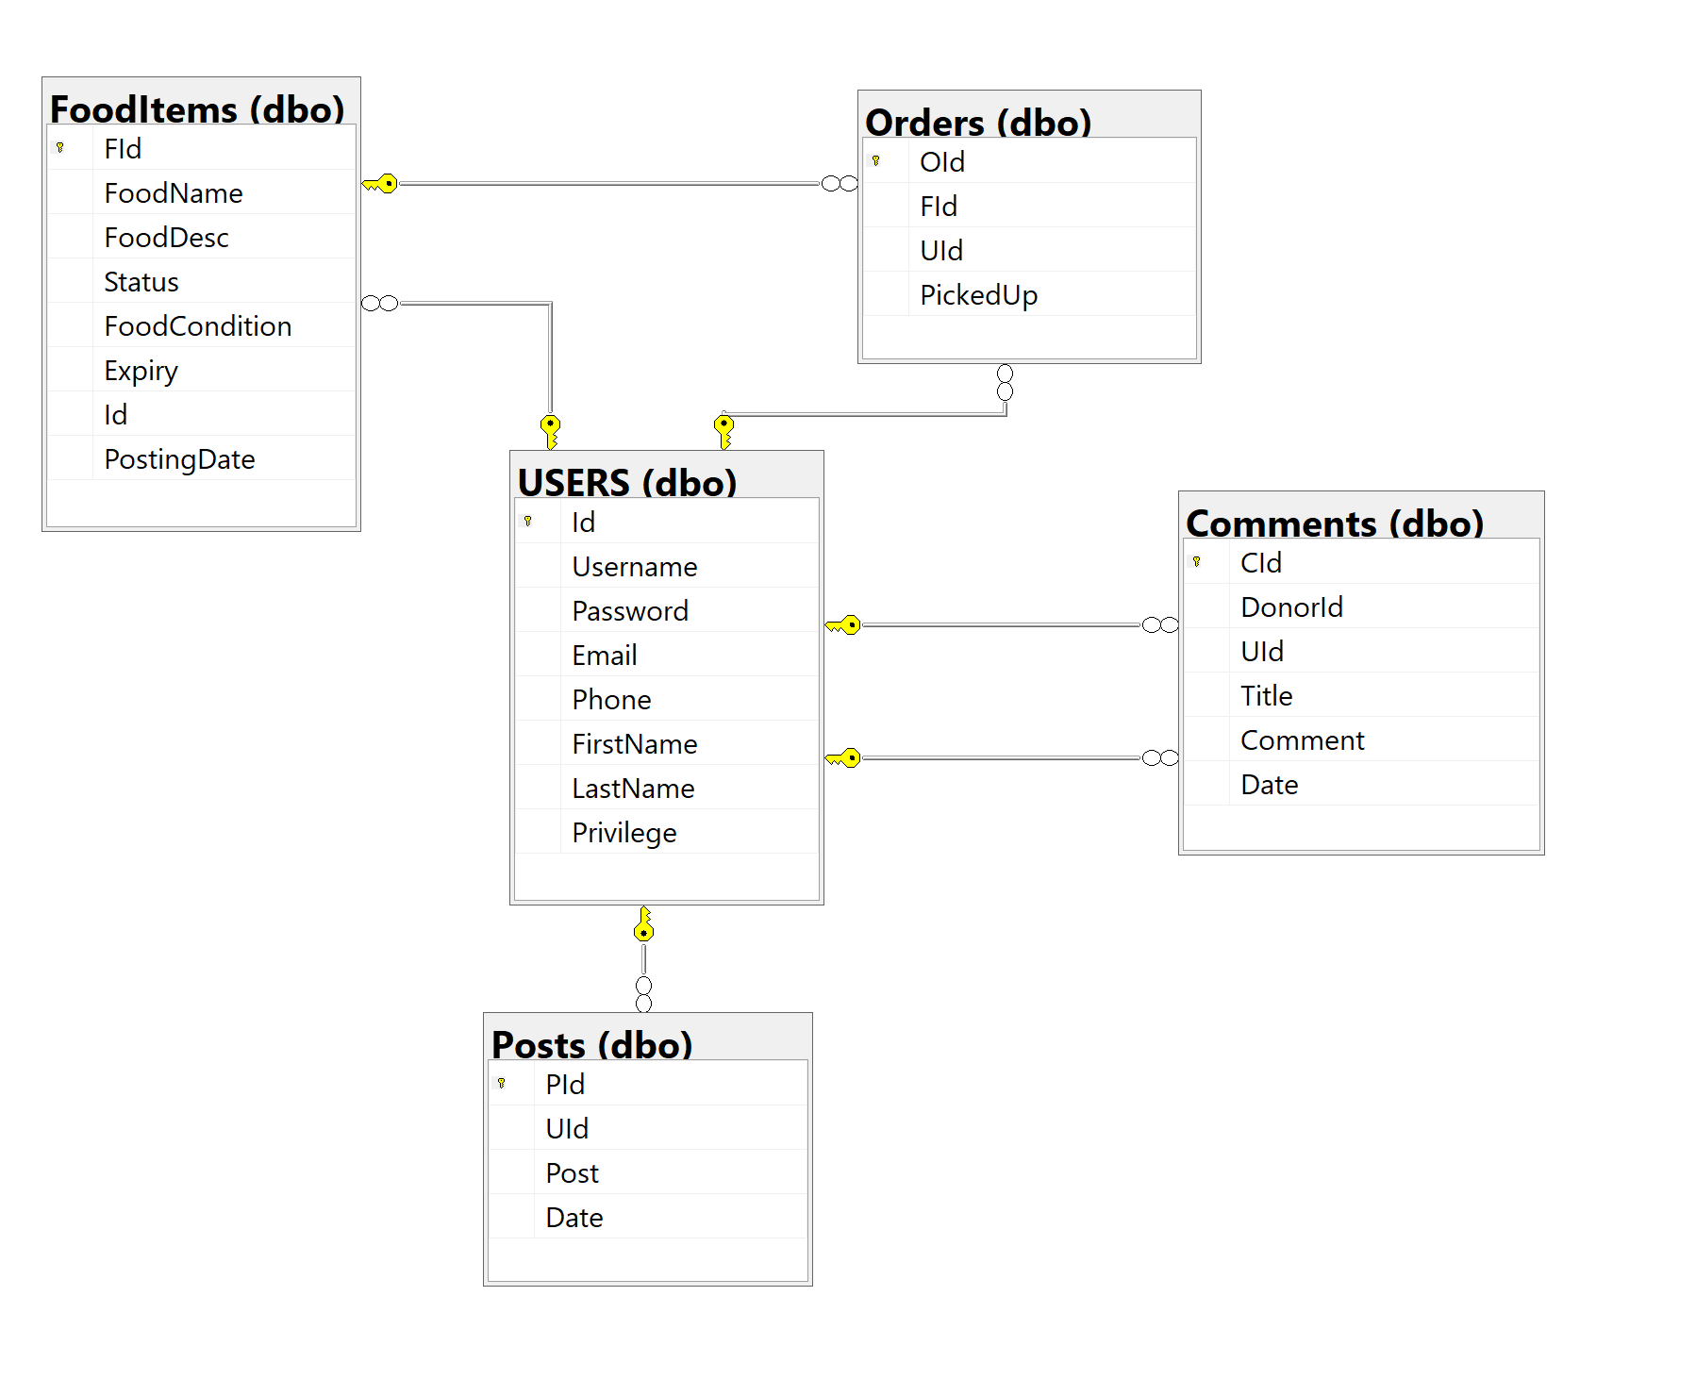

Diagram – 1